FORM 3 | UNITED STATES SECURITIES AND EXCHANGE COMMISSION  Washington, D.C. 20549  INITIAL STATEMENT OF BENEFICIAL OWNERSHIP OF SECURITIES | OMB APPROVAL  OMB Number: 3235-0104  Estimated average burden  hours per response... 0.5
 | Filed pursuant to Section 16(a) of the Securities Exchange Act of 1934 or Section 30(h) of the Investment Company Act of 1940

1. Name and Address of Reporting Person *  Ball Titus B. |  | 2. Date of Event Requiring Statement (MM/DD/YYYY)  3/19/2024 |  |  |  | 3. Issuer Name and Ticker or Trading Symbol  BeiGene, Ltd. [BGNE]
(Last) (First) (Middle)  C/O MOURANT GOVERNANCE SERVICES (CAYMAN), 94 SOLARIS AVENUE |  | 4. Relationship of Reporting Person(s) to Issuer (Check all applicable)  _____ Director _____ 10% Owner  ___X___ Officer (give title below) _____ Other (specify below)  Principal Accounting Officer /
(Street)  CAMANA BAY, GRAND CAYMAN, E9 KY1-1108  (City) (State) (Zip) |  | 5. If Amendment, Date Original Filed(MM/DD/YYYY) |  |  |  | 6. Individual or Joint/Group Filing(Check Applicable Line)  _X_ Form filed by One Reporting Person  ___ Form filed by More than One Reporting Person
Table I - Non-Derivative Securities Beneficially Owned
1.Title of Security  (Instr. 4) |  |  |  | 2. Amount of Securities Beneficially Owned  (Instr. 4) |  |  |  | 3. Ownership Form: Direct (D) or Indirect (I)  (Instr. 5) |  | 4. Nature of Indirect Beneficial Ownership  (Instr. 5)
Ordinary Shares ⁽¹⁾ |  |  |  | 23,478 |  |  |  | D
Table II - Derivative Securities Beneficially Owned (e.g., puts, calls, warrants, options, convertible securities)
1. Title of Derivate Security  (Instr. 4) | 2. Date Exercisable and Expiration Date  (MM/DD/YYYY) |  |  |  | 3. Title and Amount of Securities Underlying Derivative Security  (Instr. 4) |  |  |  | 4. Conversion or Exercise Price of Derivative Security |  | 5. Ownership Form of Derivative Security: Direct (D) or Indirect (I)  (Instr. 5) | 6. Nature of Indirect Beneficial Ownership  (Instr. 5)
 | Date Exercisable |  | Expiration Date |  | Title |  | Amount or Number of Shares
Share Option (Right to Buy) | ⁽²⁾ |  | 8/30/2033 |  | Ordinary Shares |  | 14,677 |  | $15.97 |  | D

Explanation of Responses:
(1) | Represents shares underlying unvested restricted share units.
(2) | These securities vest over a four-year period as follows: 25% on August 31, 2024 with the remaining shares vesting in 36 equal successive monthly installments thereafter, subject to continued service.

Remarks:
Exhibit List - Exhibit 24.1 - Power of Attorney

Reporting Owners
Reporting Owner Name / Address | Relationships
 | Director | 10% Owner | Officer | Other
Ball Titus B.  C/O MOURANT GOVERNANCE SERVICES (CAYMAN)  94 SOLARIS AVENUE  CAMANA BAY, GRAND CAYMAN, E9 KY1-1108 |  |  | Principal Accounting Officer

Signatures
/s/ Qing Nian, as Attorney-in-Fact |  | 3/26/2024
**Signature of Reporting Person |  | Date

Reminder: Report on a separate line for each class of securities beneficially owned directly or indirectly.
* | If the form is filed by more than one reporting person, see Instruction 5(b)(v).
** | Intentional misstatements or omissions of facts constitute Federal Criminal Violations. See 18 U.S.C. 1001 and 15 U.S.C. 78ff(a).
Note: | File three copies of this Form, one of which must be manually signed. If space is insufficient, see Instruction 6 for procedure.
Persons who respond to the collection of information contained in this form are not required to respond unless the form displays a currently valid OMB control number.

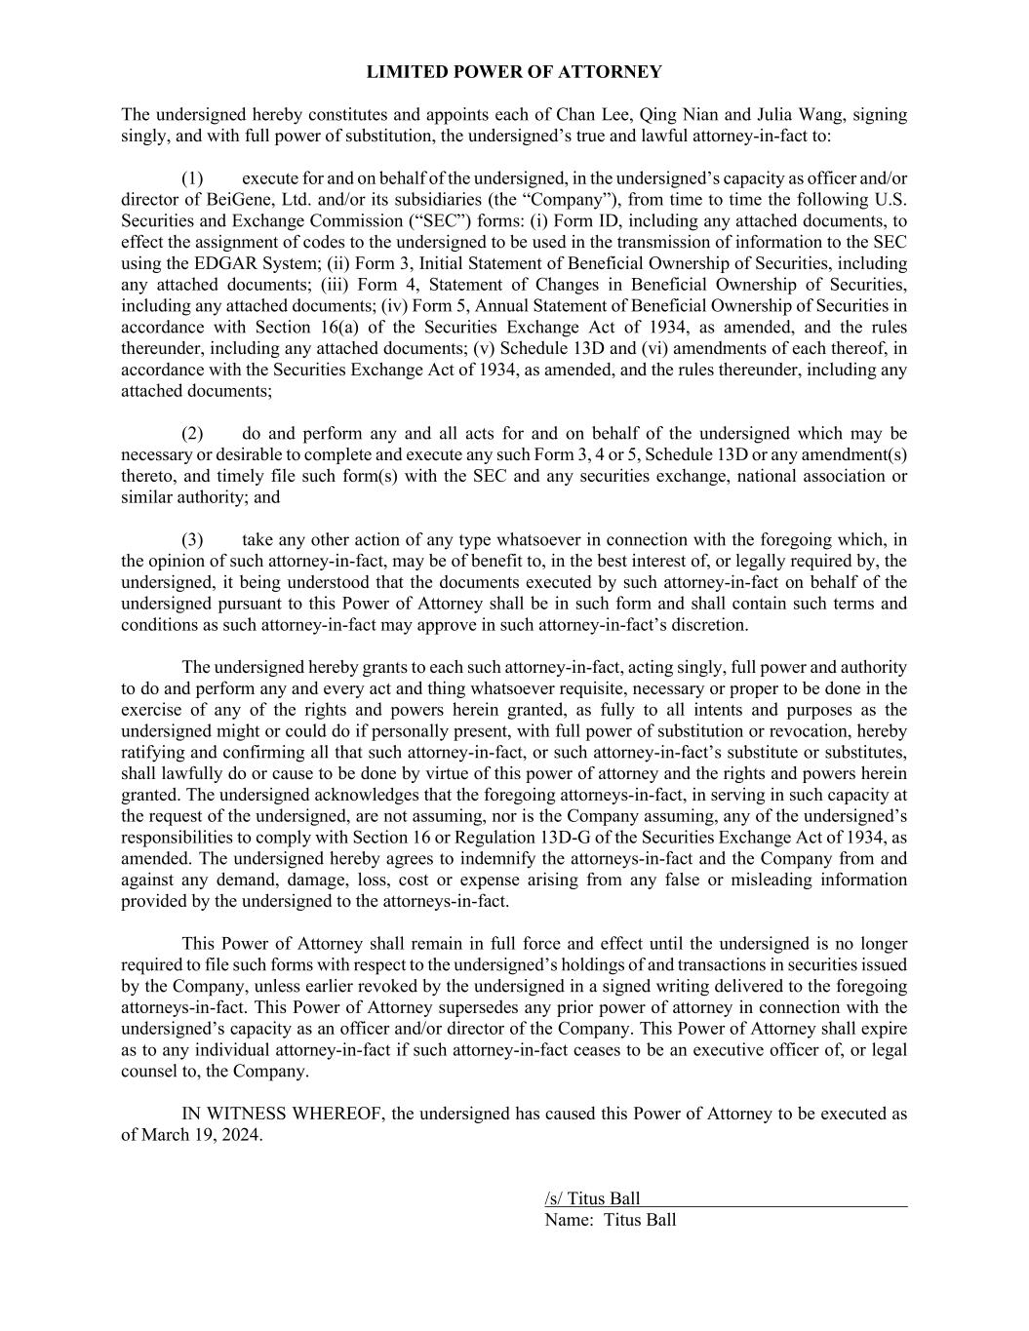
LIMITED POWER OF ATTORNEY The undersigned hereby constitutes and appoints each of Chan Lee, Qing Nian and Julia Wang, signing singly, and with full power of substitution, the undersigned’s true and lawful attorney-in-fact to: (1) execute for and on behalf of the undersigned, in the undersigned’s capacity as officer and/or director of BeiGene, Ltd. and/or its subsidiaries (the “Company”), from time to time the following U.S. Securities and Exchange Commission (“SEC”) forms: (i) Form ID, including any attached documents, to effect the assignment of codes to the undersigned to be used in the transmission of information to the SEC using the EDGAR System; (ii) Form 3, Initial Statement of Beneficial Ownership of Securities, including any attached documents; (iii) Form 4, Statement of Changes in Beneficial Ownership of Securities, including any attached documents; (iv) Form 5, Annual Statement of Beneficial Ownership of Securities in accordance with Section 16(a) of the Securities Exchange Act of 1934, as amended, and the rules thereunder, including any attached documents; (v) Schedule 13D and (vi) amendments of each thereof, in accordance with the Securities Exchange Act of 1934, as amended, and the rules thereunder, including any attached documents; (2) do and perform any and all acts for and on behalf of the undersigned which may be necessary or desirable to complete and execute any such Form 3, 4 or 5, Schedule 13D or any amendment(s) thereto, and timely file such form(s) with the SEC and any securities exchange, national association or similar authority; and (3) take any other action of any type whatsoever in connection with the foregoing which, in the opinion of such attorney-in-fact, may be of benefit to, in the best interest of, or legally required by, the undersigned, it being understood that the documents executed by such attorney-in-fact on behalf of the undersigned pursuant to this Power of Attorney shall be in such form and shall contain such terms and conditions as such attorney-in-fact may approve in such attorney-in-fact’s discretion. The undersigned hereby grants to each such attorney-in-fact, acting singly, full power and authority to do and perform any and every act and thing whatsoever requisite, necessary or proper to be done in the exercise of any of the rights and powers herein granted, as fully to all intents and purposes as the undersigned might or could do if personally present, with full power of substitution or revocation, hereby ratifying and confirming all that such attorney-in-fact, or such attorney-in-fact’s substitute or substitutes, shall lawfully do or cause to be done by virtue of this power of attorney and the rights and powers herein granted. The undersigned acknowledges that the foregoing attorneys-in-fact, in serving in such capacity at the request of the undersigned, are not assuming, nor is the Company assuming, any of the undersigned’s responsibilities to comply with Section 16 or Regulation 13D-G of the Securities Exchange Act of 1934, as amended. The undersigned hereby agrees to indemnify the attorneys-in-fact and the Company from and against any demand, damage, loss, cost or expense arising from any false or misleading information provided by the undersigned to the attorneys-in-fact. This Power of Attorney shall remain in full force and effect until the undersigned is no longer required to file such forms with respect to the undersigned’s holdings of and transactions in securities issued by the Company, unless earlier revoked by the undersigned in a signed writing delivered to the foregoing attorneys-in-fact. This Power of Attorney supersedes any prior power of attorney in connection with the undersigned’s capacity as an officer and/or director of the Company. This Power of Attorney shall expire as to any individual attorney-in-fact if such attorney-in-fact ceases to be an executive officer of, or legal counsel to, the Company. IN WITNESS WHEREOF, the undersigned has caused this Power of Attorney to be executed as of March 19, 2024. /s/ Titus Ball Name: Titus Ball

